*Florida International University*

*School of Computing and Information Sciences*

Software Engineering Focus

Final Deliverable

Project Title:

Fellowship Management 1.0

**Team Members:** Alfredo Morales, Winicius Siqueira

**Product Owner(s)**: Robert Zurita

**Mentor(s)**: Mohsen Taheri

**Instructor**: Masoud Sadjadi

The MIT License (MIT)

Copyright (c) *2016 Florida International University*

Permission is hereby granted, free of charge, to any person obtaining a copy of this software and associated documentation files (the "Software"), to deal in the Software without restriction, including without limitation the rights to use, copy, modify, merge, publish, distribute, sublicense, and/or sell copies of the Software, and to permit persons to whom the Software is furnished to do so, subject to the following conditions:

The above copyright notice and this permission notice shall be included in all copies or substantial portions of the Software.

THE SOFTWARE IS PROVIDED "AS IS", WITHOUT WARRANTY OF ANY KIND, EXPRESS OR IMPLIED, INCLUDING BUT NOT LIMITED TO THE WARRANTIES OF MERCHANTABILITY, FITNESS FOR A PARTICULAR PURPOSE AND NONINFRINGEMENT. IN NO EVENT SHALL THE AUTHORS OR COPYRIGHT HOLDERS BE LIABLE FOR ANY CLAIM, DAMAGES OR OTHER LIABILITY, WHETHER IN AN ACTION OF CONTRACT, TORT OR OTHERWISE, ARISING FROM, OUT OF OR IN CONNECTION WITH THE SOFTWARE OR THE USE OR OTHER DEALINGS IN THE SOFTWARE.

***Abstract***

*This document presents the information necessary to gain a good understanding of Fellowship Management 1.0 (FM 1.0). FM 1.0 is a web platform made for graduate students so they can apply for fellowship opportunities. FM 1.0 has an easy to use web interface that allows administrators to manage users and fellowships. FM 1.0 uses the Windows, Apache, Mysql, and PHP stack.*

**Table of Contents**

**Introduction** …………………………………………………………………………………………………………………………….. 5

Current System ……….…………………………………………………………………………………………………………... 5

Purpose of New System …………………………………………………..…………………………………………...……... 5

**User Stories**

Implemented User Stories ………………………………………….………………………………………………………..7

Pending User Stories …………………………………………………………………...…………………………….....….. 10

**Project Plan**

Hardware and Software Resources ……………………………………………………...……………...……….… 12

Sprints Plan ……………………………………………………………..………………………………………………………. 13

*Sprint 1*  …………………………………………………………………………………………………………………………... 13

*Sprint 2*  …………………………………………………………………………………………………………………………... 13

*Sprint 3*  …………………………………………………………………………………………………………………………... 13

*Sprint 4*  …………………………………………………………………………………………………………………………... 13

*Sprint 5*  …………………………………………………………………………………………………………………………... 13

*Sprint 6*  …………………………………………………………………………………………………………………………... 13

*Sprint 7*  …………………………………………………………………………………………………………………………... 13

**System Design**

Architectural Patterns ………………………………………………………………………………………………….. 14

System and Subsystem Decomposition …………………………………………………………………………….… 14

Deployment Diagram …………………………………………………………………………………………………….…... 15

Design Patterns ………………………………………………………………………………………………………….….... 15

**System Validation**  ……………………………………………………………………………………………………………….15

**Glossary**  ……………………………………………………………………………………………………………………………….16

**Appendix**  ………………………………………………………………………………………………………………………………….38

Appendix A - UML Diagrams ………………………………………………………………………………………………. 17

*Static UML Diagrams*  ……………………………………………………………………………………………………….17

*Dynamic UML Diagrams*  …………………………………………………………………………………………………..18

Appendix B - User Interface Design …………………………………………………………………………….…... 19

Appendix C - Sprint Review Reports …………………………………………………………………………...…… 20

Appendix D - User Manuals, Installation/Maintenance Document, Shortcomings/Wishlist Document and other documents …………………………………………………………………….…………… 21

**References** …………………………………………………………………………………………………………………………...22

# Introduction

This document presents the information necessary to gain a good understanding of Fellowship Management 1.0 (FM 1.0). FM 1.0 is a web platform made for graduate students so they can apply for fellowship opportunities. FM 1.0 has an easy to use web interface that allows administrators to manage users and fellowships. FM 1.0 uses the Windows, Apache, Mysql, and PHP stack.

## Current System

The current system is a static website. It requires knowledge of HTML to update, and HTML is hard to read for someone who does not have programming experience.

## Purpose of New System

The new system will allow the owner to show list of fellowships available to students. Students will be able to apply to fellowships. Owner will provide solution that is easy to use for both students and administrator.

# User Stories

The following section provides the detailed user stories that were implemented in this iteration of the Fellowship Management 1.0 project. These user stories served as the basis for the implementation of the project’s features. This section also shows the user stories that are to be considered for future development.

## Implemented User Stories

User Story #132: Register Profile

**Use Case**

* Name: Register Profile
* Actor: Regular User
* Preconditions: The user has clicked the “Create Profile” link
* Description <Flow of events>: If the regular user types in a username that is already taken and submits the form, then no profile is created. The regular user is prompted to enter a username that is not taken. The user types in a username that is not taken and submits the form. A profile is created. The user can login to his/her newly created profile.

User Story #149: Remove Fellow

**Use Case**

* Name: Remove Fellow
* Actor: Admin User
* Preconditions: The Admin User is logged in and is viewing the Users List page.
* Description <Flow of events>: The Admin User clicks the “Delete” link on a row that is associated with a fellow. The Admin User is prompted “Are you sure?”. If the Admin User clicks Ok, then the fellow is removed from the list. If the Admin User clicks Cancel, then the fellow stays on the list.

User Story #138: Create Fellowship

**Use Case**

* Name: Create Fellowship
* Actor: Admin User
* Preconditions: The Admin User has logged in, navigated to the /admins/fellowships/ page, and clicked the “Add Fellowship” link.
* Description <Flow of events>: The Admin User fills out the form completely and clicks submit. If there are no errors, then the fellowship can be viewed in the home page. If there was an error, then the user is sent back to the form to correct the error.

User Story #139: Edit Fellowship

**Use Case**

* Name: Edit Fellowship
* Actor: Admin User
* Preconditions: The Admin User has logged in, and from the following URL <http://localhost/fellowship/app/> the Admin User clicked on “Edit”.
* Description <Flow of events>: The Admin User fills out the form completely and clicks submit. If no fields are empty, and the Admin User clicks “Update Fellowship”, then the updated fellowship can be viewed in the home page. If a field is empty, then the user is sent back to the form to fill the empty field.

User Story #146: Remove Fellowship

**Use Case**

* Name: Remove Fellowship
* Actor: Admin User
* Preconditions: The Admin User has logged in and is in the /admins/fellowships/ page.
* Description <Flow of events>: The Admin User clicks the “Delete” link for a fellowship. A prompt will appear asking the user “Are you sure?”. If the user clicks “OK”, then the fellowship will be deleted from the fellowship list, and the page will reload. If the user clicks “Cancel”, then the fellowship will not be deleted from the fellowship list.

## Pending User Stories

User Story #133: View Fellowship Detail

User Story #134: Apply to Fellowship

User Story #135: Unapply to Fellowship

User Story #136: Logout

User Story #137: Edit Own Profile

User Story #140: View Applicants for a Fellowship

User Story #141: Remove Applicant from a Fellowship

User Story #142: Login

User Story #143: Grant Fellowship to Student Who Applied for Fellowship

User Story #144: View Fellowship List

User Story #145: View List of Fellowships Applied To

User Story #147: Create Admin User

User Story #148: Remove Admin User

User Story #unnumbered1: Recover Password

User Story #unnumbered2: Email Notification

# Project Plan

This section describes the planning that went into the realization of this project. This project incorporated the SCRUM development techniques and as such required the sprints to be planned. The sprint plannings are detailed in the section. This section also describes the components, both software and hardware, chosen for this project.

## Hardware and Software Resources

The following is a list of all hardware and software resources that were used in this project:

Laptop:

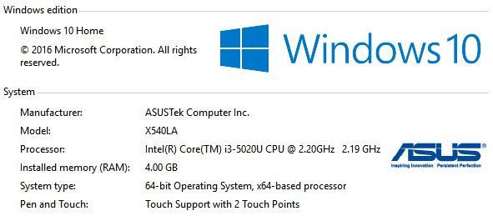

Software:

WAMP Version 3.0.6 - 64bit

(includes Apache, Mysql, and PHP):

Apache Version: 2.4.23

Mysql Version: 5.7.14

PHP Version: 5.6.25

CakePHP 3 runs on PHP 7.1 (min. PHP 5.6.0)

## Sprints Plan

### Sprint 1

Communicated with David Driesbach about the requirements.

### Sprint 2

Winicius worked on User Story #132, created sprint video and feature document.

Alfredo worked on User Story #118, created sprint video and feature document.

### Sprint 3

Winicius worked on User Story #149, created sprint video and feature document.

Alfredo worked on User Story #129, created sprint video and feature document.

### Sprint 4

Winicius worked on User Story #138, created sprint video and feature document.

Alfredo worked on User Story #154, created sprint video and feature document.

### Sprint 5

Winicius worked on User Story #139, created sprint video and feature document.

Alfredo worked on User Story #164, created sprint video and feature document.

### Sprint 6

Winicius worked on User Story #146, created sprint video and feature document.

### Sprint 7

We worked on Poster, Presentation Slides, and Final Document.

# System Design

This section contains information on the design decisions that went into this project. The architecture patterns are outlined and explained. The entire system is shown in a package diagram and the subsystems are explained. Finally, the design patterns used in the project are discussed.

## Architectural Patterns

CakePHP3 uses Model View Controller (MVC). MVC is a software architectural pattern for implementing user interfaces on computers. It divides a given application into three interconnected parts in order to separate internal representations of information from the ways that information is presented to and accepted from the user [2].

## System and Subsystem Decomposition

The system runs on Windows 10, and uses the WAMP server. The WAMP server includes an Apache web server, a MySQL database server, and PHP.

MySQL is the world’s most popular open-source database. PHP is a popular general-purpose scripting language that is especially suited to web development. CakePHP 3 is a web development framework running on PHP 7.1 (min. PHP 5.6.0)

## Deployment Diagram

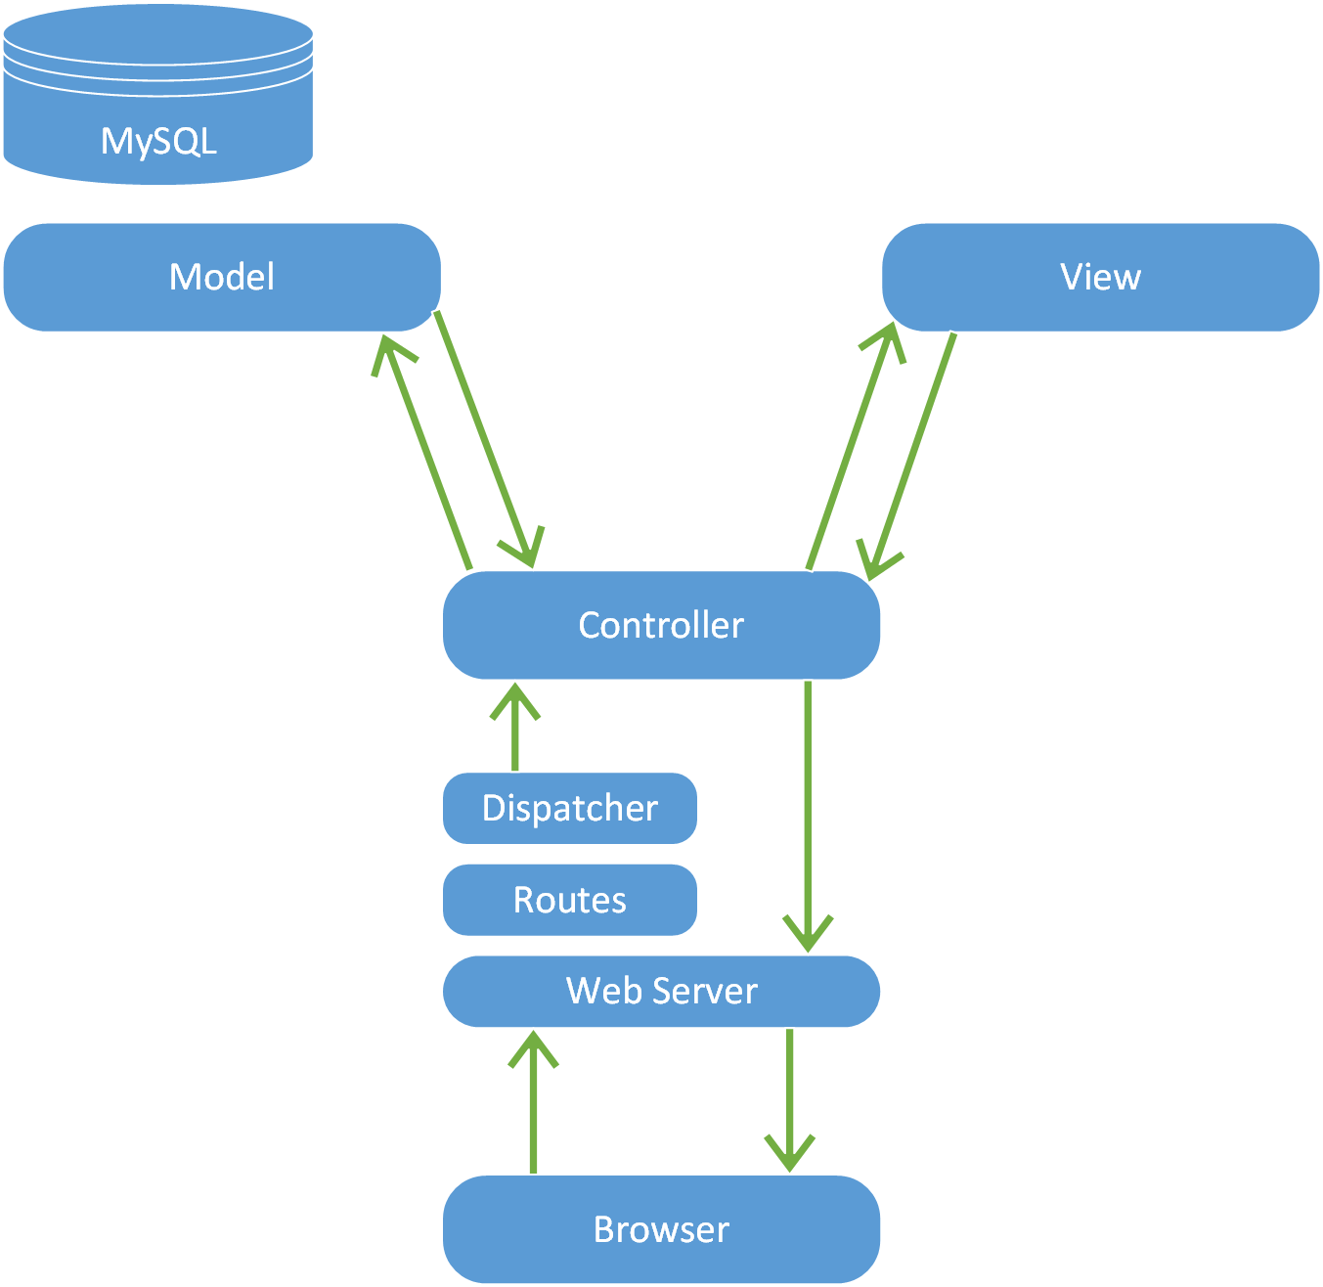

## Design Patterns

Design patterns represent the best practices used by experienced object-oriented software developers. Design patterns are solutions to general problems that software developers faced during software development. These solutions were obtained by trial and error by numerous software developers over quite a substantial period of time [3]. MVC design pattern decouples the model-view-controller allowing for efficient code reuse and parallel development [2].

# System Validation

To validate the system we are using PHP Unit. Here are two of the Unit Tests we use to validate the system.

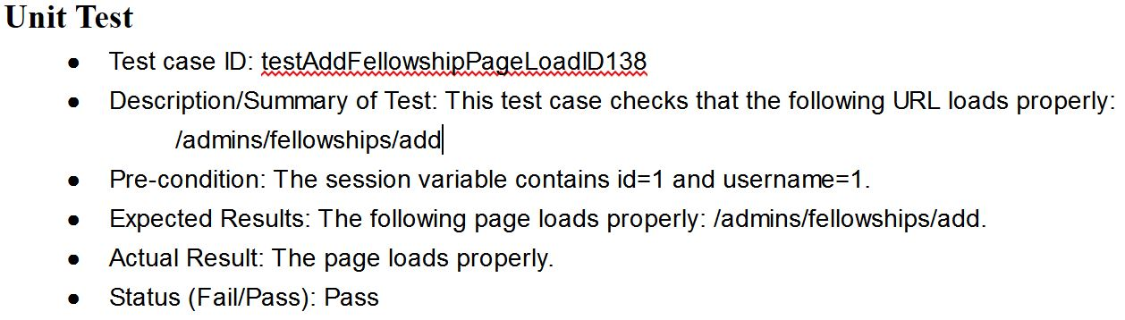

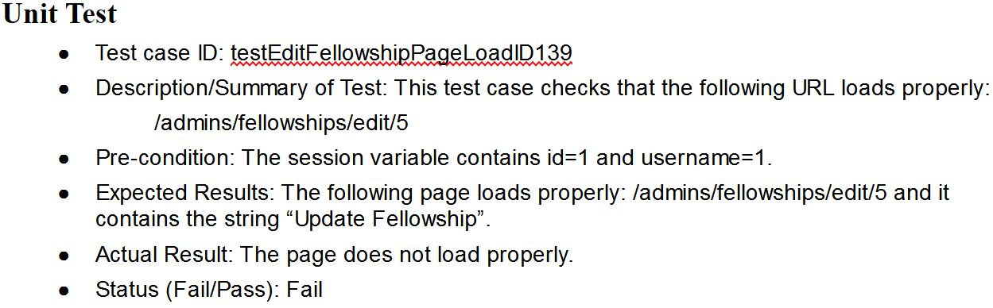

# 

# 

# 

# Glossary

Windows OS: is a proprietary operating system.

Apache Server: is a webserver.

MySQL: is the world’s most popular open-source database.

PHP: is a popular general-purpose scripting language that is especially suited to web development.

CakePHP 3: is a web development framework running on PHP 7.1 (min. PHP 5.6.0)

Model-View-Controller: is a software architectural pattern for implementing user interfaces on computers.

# Appendix

## Appendix A - UML Diagrams

## UseCaseDiagram For Fellowship Management.jpg

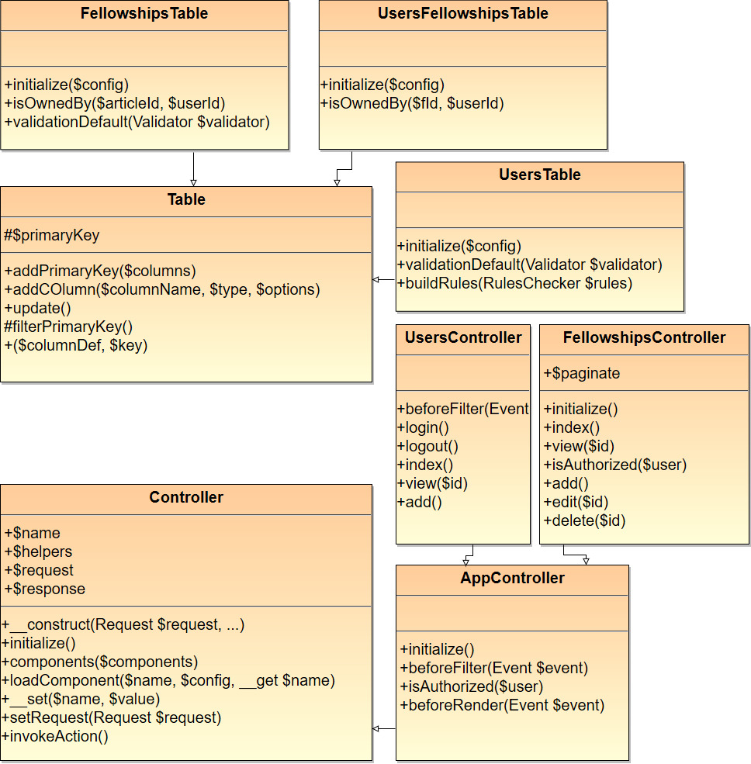

## 

## Appendix B - User Interface Design

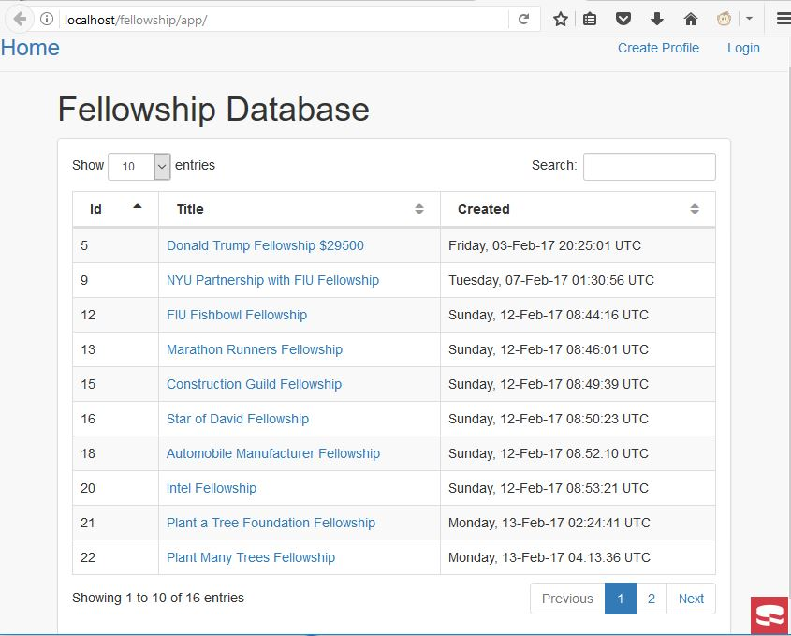

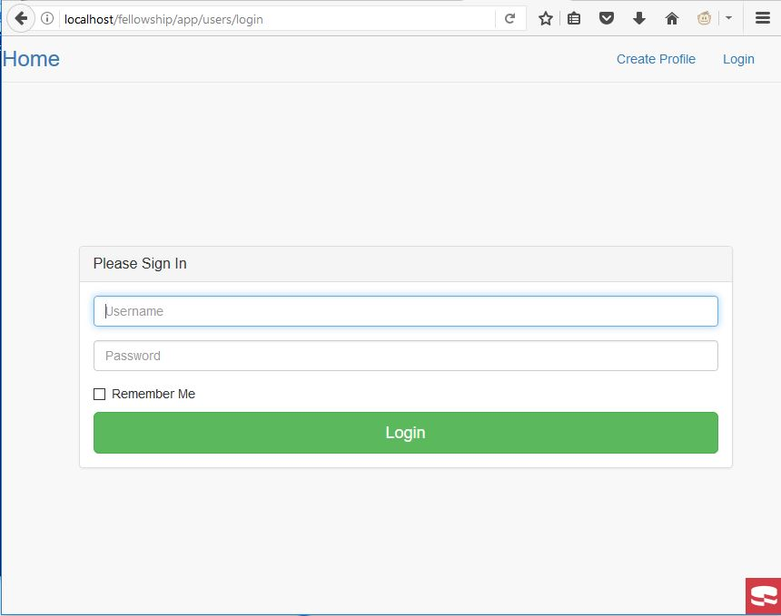

## Appendix C - Sprint Review Reports

SP1 - We met with David Driesbach and got the requirements for the project.

SP2 - We decided on using WAMP as the implementation for the project.

SP3 - We installed WAMP and created a Use Case Diagram and the database.

SP4 - We worked on a user story, created a feature document, video, and unit test.

SP5 - We worked on a user story, created a feature document, video, and unit test.

SP6 - We worked on a user story, created a feature document, video, and unit test.

SP7 - We created final document, final presentation, and poster.

## Appendix D - User Manuals, Installation/Maintenance Document, Shortcomings/Wishlist Document and other documents

**User Manuals:**

Guest User Role:

This user is allowed to register a unique username with a password. This user can also view the list of fellowships and the details of each fellowship.

Fellow User Role:

This user can do the same thing as a guest user; in addition, this user can login and while logged in this user can apply to a fellowship and unapply to a fellowship. This user can also logout.

The default fellow user has the following credentials:

Username: f

Password: f

Admin User Role:

This user can do the same thing as a fellow user; in addition, this user can view all registered users, change a user’s account information (e.g. username, password, gpa), create/remove/update/delete users and fellowships.

The default admin user has the following credentials:

Username: w

Password: w

**Installation/Maintenance Document:**

This web application uses WAMP. The web development framework it uses is CakePHP 3.3.

Apache version: 2.4.23 Mysql version: 5.7.14 PHP version: 5.6.25

Download WAMP Server from <http://www.wampserver.com/en/>

Download MySQL Workbench from <https://www.mysql.com/products/workbench/>

Install MySQL Workbench by running the executable.

Install WAMP by running the executable.  
The following software will be installed: Apache Server, MySQL Server, and PHP.

Check that the WAMP icon is green like image:

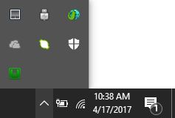

After you have the WAMP webserver running.

You can connect to the MySQL Database using the following credentials:

Host: localhost

Username: root

Password: <no password, leave this field blank>

You will then need to create the schema in your mysql server by running the my_fellowship.sql file found in the /Database/ directory.

Now download the GitHub repository, extract the file, and copy the content in /Code/ into your WAMP directory.  
  
My wamp directory is: C:\wamp64\www\fellowship\app

Edit the file /fellowship/app/config/app.php by changing the following lines to correspond to your mysql server configuration: 'Datasources' => [ 'default' => [ 'className' => 'Cake\Database\Connection', 'driver' => 'Cake\Database\Driver\Mysql', 'persistent' => false, 'host' => 'localhost', /** * CakePHP will use the default DB port based on the driver selected * MySQL on MAMP uses port 8889, MAMP users will want to uncomment * the following line and set the port accordingly */ //'port' => 'non_standard_port_number', 'username' => 'root', 'password' => '', 'database' => 'my_fellowship', 'encoding' => 'utf8', 'timezone' => 'UTC', 'flags' => [], 'cacheMetadata' => true, 'log' => false,

To navigate to the homepage type the following in your browser's address bar:<http://localhost/fellowship/app/>

If everything works then you should see the webpage with content.

**Shortcomings/Wishlist Document:**

The website does not have password recovery and a user story to go along with it. There are many user stories that still need to be worked on.

# Videos

Introductory Video: <https://youtu.be/MRbtvDj3n9A>

Regular User Role Actor Video: <https://youtu.be/gcVUXU3EG_I>

Fellow User Role Actor Video: <https://youtu.be/ncD1TLSCOmE>

Admin User Role Actor Video: <https://youtu.be/rf_5lsF0B98>

Installation & Maintenance Video: <https://youtu.be/Hs42j-1PBHE>

Shortcomings & Wishlist Video: <https://youtu.be/T7N1yv3hQPM>

# References

1. <https://book.cakephp.org/3.0/en/index.html>
2. <https://en.wikipedia.org/wiki/Model%E2%80%93view%E2%80%93controller>
3. <https://www.tutorialspoint.com/design_pattern/design_pattern_quick_guide.htm>
4. <https://app.pluralsight.com/library/courses/introduction-php-mvc-cakephp/table-of-contents>